**Assignment 4.1**

1.Histogram for all variables in a dataset mtcars. Write a program to create histograms for all columns.

library(ggplot2)

library(tidyr)

mtcars %>%    gather() %>% ggplot(aes(value)) +  facet_wrap(~ key, scales = "free") + geom_histogram()

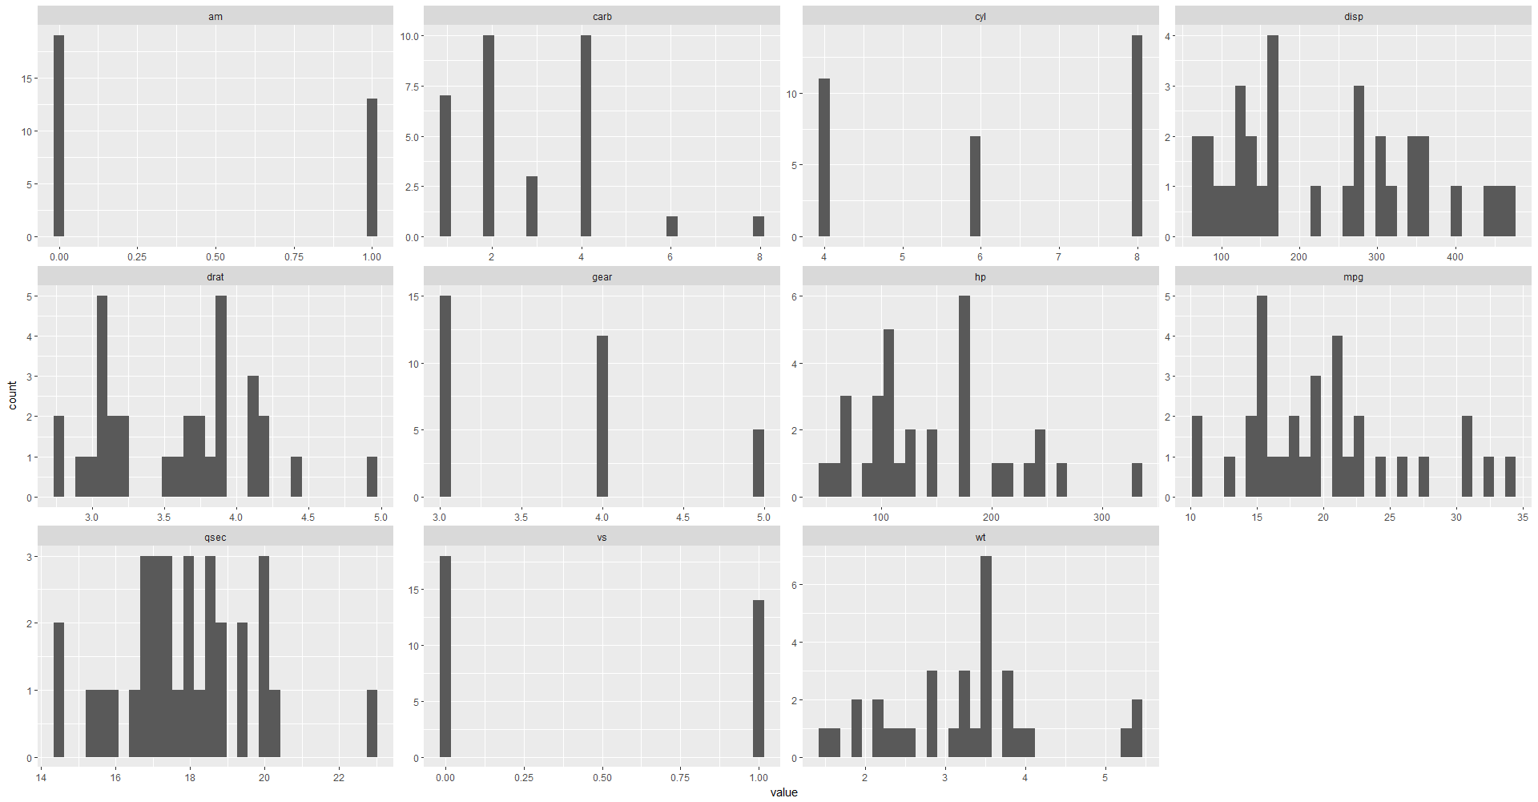

2) Write a program to create box plot for all variables.

Ans.- boxplot(mtcars)

